Title : AV Receiver GUI controller

This project was designed to control the AV Receiver system with LVGL-enabled touch LCD.

Actually, the AV receiver is a very complicated home theater system to complete this project within a short time.

So, in this GUI demo, there is no system linkage. But if I have more time, I will add a system connection feature with an actual H/W device in the future.

**How it is configured/working?**

Once power cable is connected, it will draw a booting animation logo.

I used RT-Thread logo image existed on the RTT official Git-hub.

After boot-up, circular scrollbar will show up. It has 8 list to control the system.

1. Volume : It can control the system master volume with touching.
2. Input Select : It can control the system input source by pressing the next/prev icon button.
3. Speaker Setup: It can control the number of speaker system.
4. Speaker Config: It can show how the speaker system is configured.
5. Speaker Edit: It can change each speaker’s setting.
6. Preference : It can set the user preference/convenience settings.
7. Network Setup: It can set the IP address / Subnet mask / Gateway / DNS for the networking system.
8. System Info: It can show the System information like each device's version, serial number..etc. In this demo, the RT-Thread OS version, and LVGL version will be displayed.

In this demo version, no EEPROM data backup so after AC cycle, all data will be reset with it’s default value. Until the main power is turned off, edited data will be remained.

**How to compile?**

Download RT-Thread studio from the RT-Thread official site, and import the “imxrt1060evkb_rtt_contest” project.

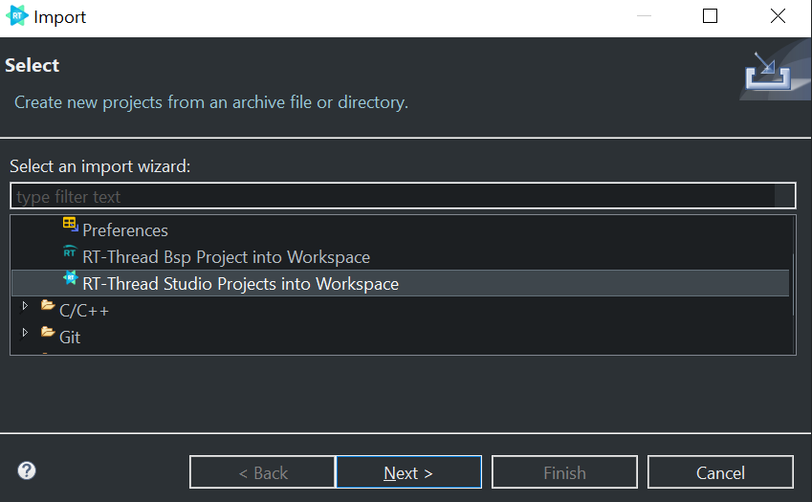

After importing is successfully done, the build the project.

RT-Thread Studio doesn’t support DAP-LINK which IMXRT1060EVKB default equipped download debugger, so a separate J-link debugger is required to download executable binary via RT-Thread studio.

So, please check the RT-Thread Studio’s debugger setting with J-Link.

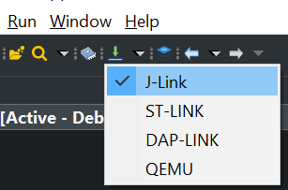

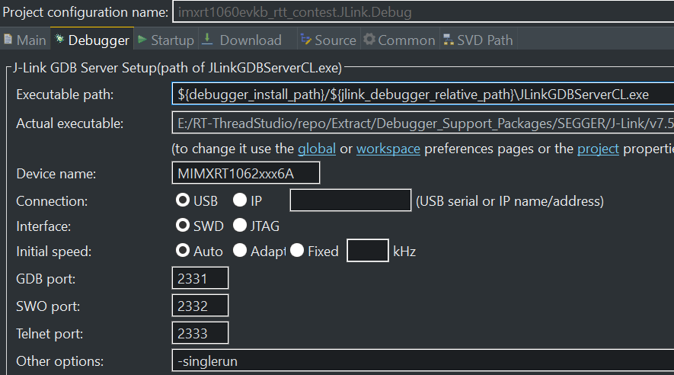

Default EVKB HW debug setting is it’s default DAP-Link debugger connection so if J-Link is used, J9, J10 should be opened before J-Link connecting.

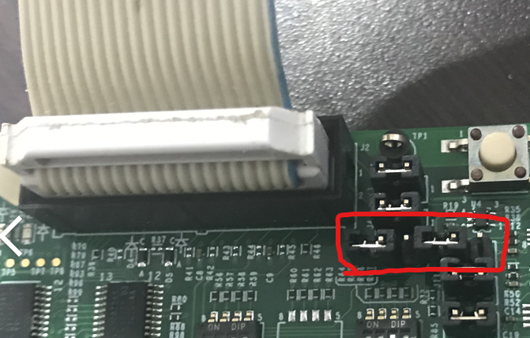

If there is no J-Link debugger to download the executable binary file, we can download the binary by just dragging & dropping the “rtthread.bin” into the RT1060-EVK driver after building the project.

